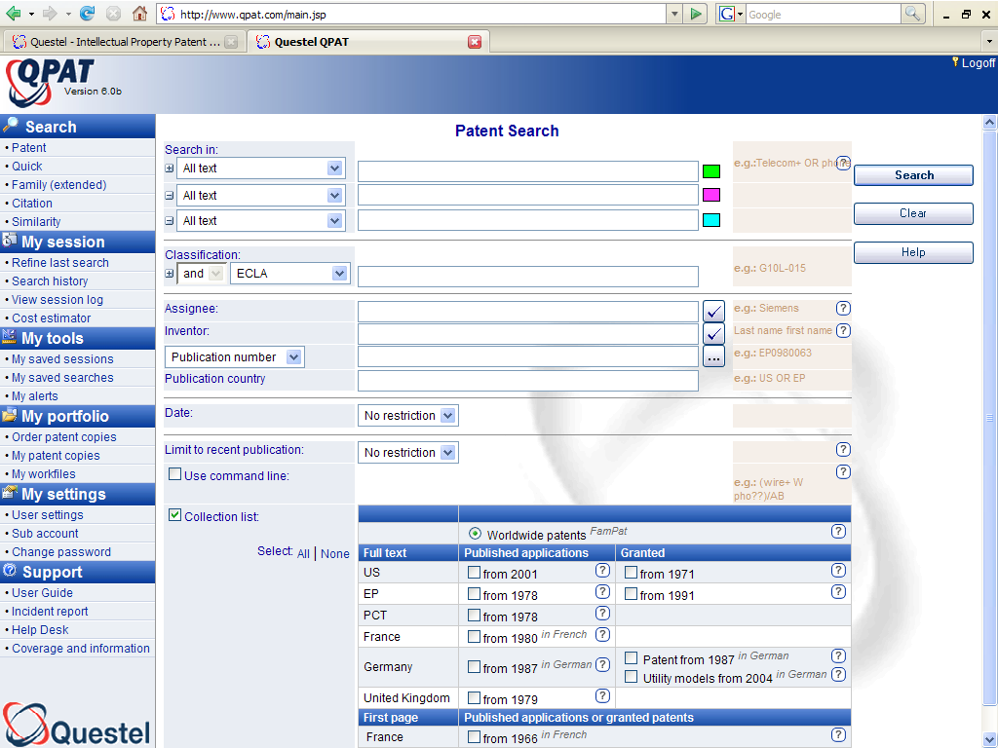
Combine all operators :
truncations, proximity, boolean
The AND operator combines all fields
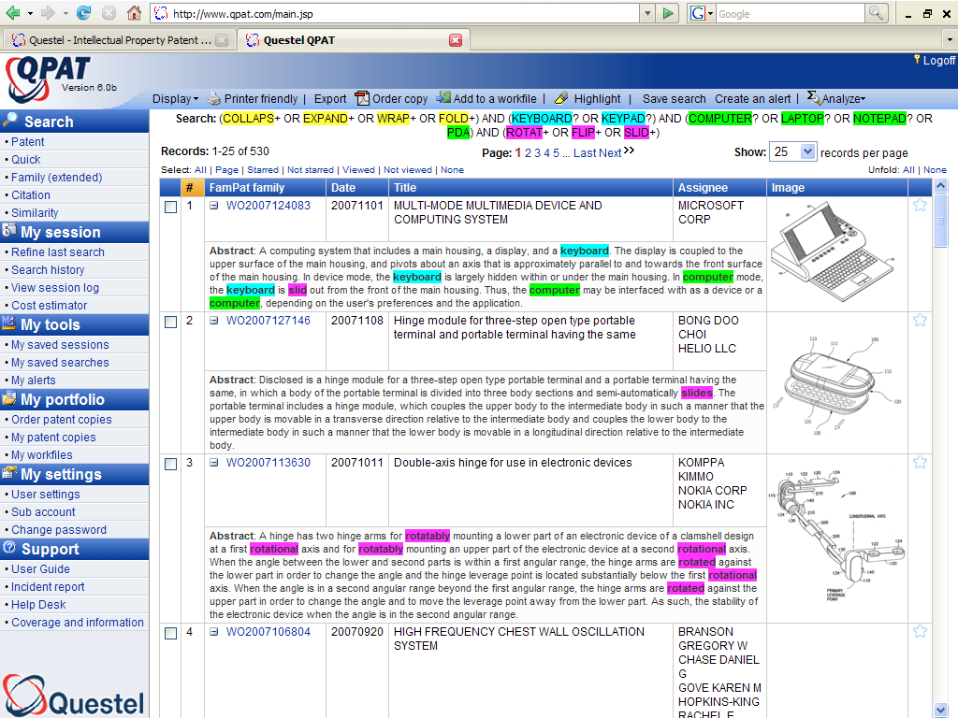
Unfolded view :
Highlighted concepts
in title & abstracts
with front page image
Click on image for mosaic
of other drawings

Truncations
+ | Retrieves an unlimited number of characters | bicycl+ +inflamatory
? | Retrieves zero or one character | bicycle? alumin?um
# | Retrieves exactly one character | polymeri#ation

Operators
OR | Retrieves references containing at least one of the terms | sulfur OR sulphur
AND | All the terms | plutonium AND isotope
NOT | The first term without the second | suv NOT vesicle
F | The terms in the same field | sodium F chlorine
S | The terms in the same sentence | sodium S chlorine
P | The terms in the same paragraph | sodium P chlorine
D | The terms next to each other in any order | Redundancy D check+
Nd | The terms next to each other in any order with up to n other terms between them (n from 1 to 9) | electric+ 2D conduct+ 2D adhesive
W | The terms next to each other in a specific order. When no operator is put between terms, the W will be automatically implied | smart W card? = smart card?
nw | The terms next to each other in a specific order with up to n other terms between them (n between 1 and 9) | friction 1W pad?
Parenthesis | Parenthesis necessary when combining several operators | ((wireless W application W protocol) OR wap) NOT (dna OR transgenic)  (hair 1D (dye OR dyeing)) AND oxidat+

Patent number formats :
PCT | Application published before 2000 – A1 or A2  Application published after 1999 - A1 or A2  Publication of the international search report - A3 | WO9909126  WO200113126  WO200269126A3
EUROPE | Application published - A1 or A2  Search Report - A3  Granted patent - B1  Patent after modification - B2 | EP1303142  EP1303142A3  EP-929467B1  EP-839080B2
FRANCE | Patent Application  Granted patent (From January 2000)  Application for additional patent certificate  1st Application for Utility model | FR2801469  FR2783402B1  FR2749399A2  FR2850854A3
GERMANY | Patent application- A  Examined patent application - B :  Granted patent - C1 :  Granted patent - C2 :  Utility model - U1 : | DE19964155  DE1588442B  DE19937847C1  DE3011714C2  DE20300841U1
UNITED KINGDOM | Published patent application :  Granted patent : | GB2346402  GB24112380B
NETHERLANDS |  | NL9301238
JAPAN | Unexamined patent application - Kokai A : from 2000, type the 4-digit year. JP 2001/123  Unexamined patent application - Kokai A : before 2000, type the 2-digit imperial year. JP 50 /123 A (1975) must be typed | JP2001000123  JP50000123
USA | Patent Application  Granted patent  Design patent  Reissued patent  Statutory Invention Registration (SIR)  Defensive publication | US20010001328  US4445644  USD442761  USRE38244  USH001951  UST109201
AUSTRALIA | Published patent application  Granted patent : | AU2005211606  AU725779
AUSTRIA |  | AT-403869
ITALY |  | IT1211973

